What is your current level of study? _______________________________________________________

What level of study are you applying to? ___________________________________________________

New York State Dream Act Eligible?
- Yes
- No
- Unsure

- 1. Status requirements: Select the immigrant status the applies to you:
- T-Visa
- U-Visa
- Temporary Protected Status (TPS)
- Deferred Action for Childhood Arrivals (DACA)
- Undocumented or without any lawful immigrant status
- U.S. Citizen
- Permanent Resident (Green Card)
- Paroled Refugee
- 2. Education Requirements: If you fit one of the descriptions below, you may be eligible for one or more NYS student financial aid awards under the DREAM Act:
- You attended a NYS high school for 2 or more years, graduated from a NYS high school, and enroll or enrolled for undergraduate study at a NYS college within 5 years of receiving your NYS high school diploma
or
- You attended a NYS high school for 2 or more years, graduated from a NYS high school, and enroll or enrolled for graduate study at a NYS college within 10 years of receiving your NYS high school diploma
or
- You received a NYS high school equivalency diploma, and enroll or enrolled for undergraduate study at a NYS college within 5 years of receiving your NYS high school equivalency diploma
or
- You received a NYS high school equivalency diploma, and enroll or enrolled for graduate study at a NYS college within 10 years of receiving your NYS high school equivalency diploma
or
- You are or will be charged the NYS resident in-state tuition rate at a SUNY or CUNY college for a reason other than residency.
- 3. Residency Requirement: Are you currently a resident of New York State?
  - Yes.
  - No.
  - Unsure.
WHAT YOU NEED TO APPLY
- 4. Documents needed to submit NYDA application: The following documents are required to complete your eligibility verification application. If you are without lawful immigration status, or if you or your parent(s) do not have an SSN or TIN, please remove your street address and/or parent name(s) from all documents before uploading.
  - Proof of Citizenship or Immigration Status: You must provide your I-797 (Notice of Action, with an I-94 at the bottom of page) or Visa to provide evidence for the immigration status you selected. Providing this depends on status and requested documents.
    - I -797: Notice of Action, with an I-94 at the bottom of page.
    - Visa: _________________
    - No proof of Citizenship or Immigration Status needed
  - Proof of Education: New York State High School Transcript, Diploma (if necessary), or Equivalency Diploma Documentation:
  - High School Transcript: If you received a New York State high school diploma, you must provide a transcript(s) from a New York State high school showing you were in attendance for at least two (2) years. Please note: If your transcript does not clearly indicate your graduation date, you must also provide your diploma. (Upload your transcript(s) and diploma as a .zip file by referring to the Upload FAQ.)
or
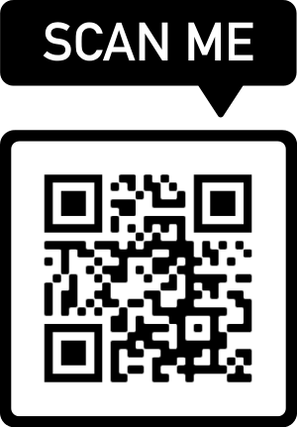
  - New York State High School Equivalency Diploma Documentation: If you obtained your New York State high school equivalency diploma, you must upload your documentation. (The document must display the HSE ID Number.) Official transcripts are not required; you may upload unofficial transcripts. Your full name must be visible on all documentation provided. Your transcript should be a full transcript, showing all grades, not just a grade report
WHERE TO APPLY:
https://www.hesc.ny.gov/dream
Contact Information:
If you have any questions during your application process, please
contact UnLocal at 646.216.8210 or email info@unlocal.org.

